**Name: B.Saron**

**Reg no: RA2211003050115**

**Class: CSE B**

**CN LAB Procedures**

**Lab 7: Implementation of RIP Version 1**

* **Procedure:**

1. **Open Packet Tracer:**
   * Launch Cisco Packet Tracer on your computer.
2. **Create a Network:**
   * Drag three routers onto the workspace and connect them in a linear topology.
   * Connect a computer to each router using Ethernet cables.
3. **Configure IP Addresses:**
   * Assign IP addresses to each interface on the routers and computers.
4. **Enable RIP Version 1:**
   * Access the CLI of each router.
   * Enable RIP routing: router rip, version 1.
   * Advertise connected networks: network <network address>.
5. **Test Connectivity:**
   * Use the ping command to test connectivity between the computers.

# Output:

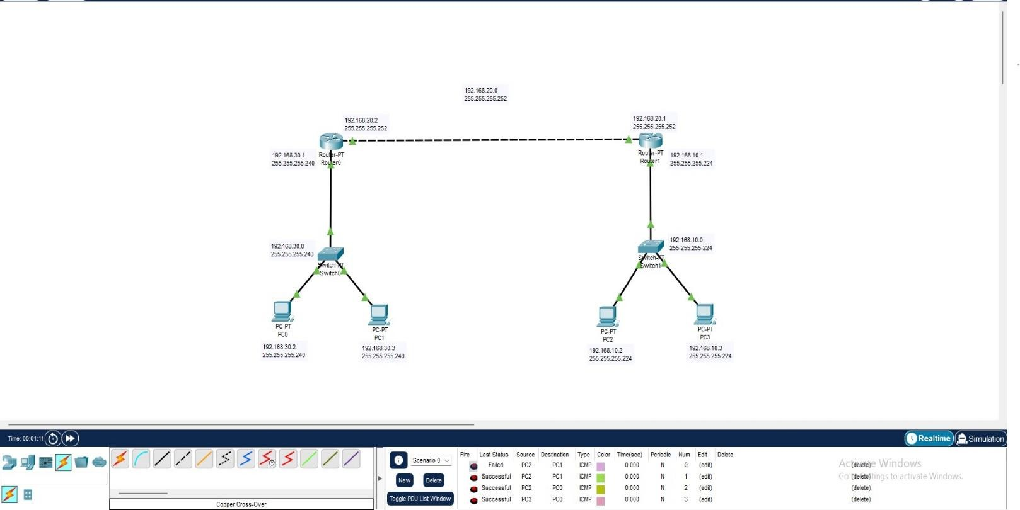

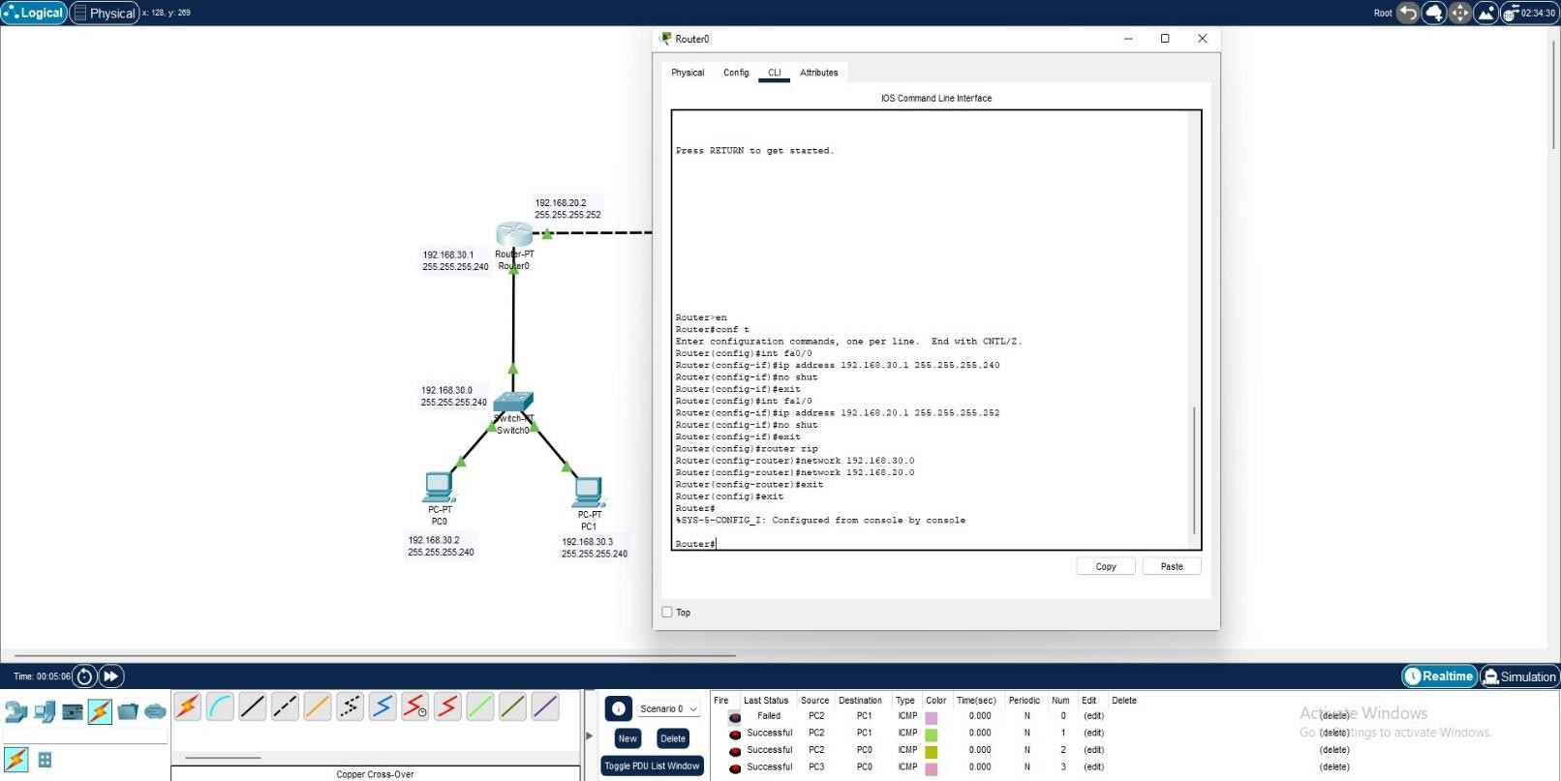

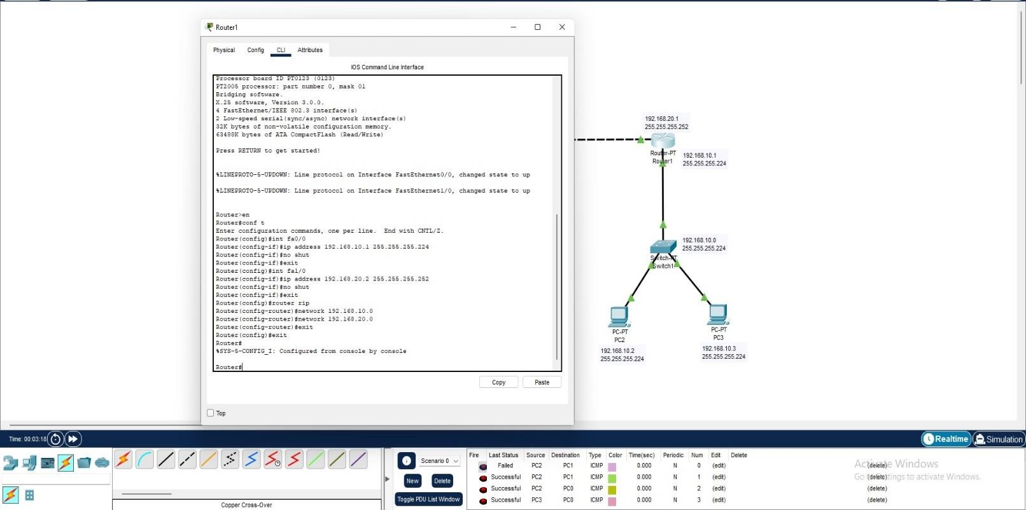

**Lab 8: Implementation of RIP Version 2**

* **Procedure:**

1. **Open Packet Tracer:**
   * Launch Cisco Packet Tracer on your computer.
2. **Create a Network:**
   * Drag three routers onto the workspace and connect them in a linear topology.
   * Connect a computer to each router using Ethernet cables.
3. **Configure IP Addresses:**
   * Assign IP addresses to each interface on the routers and computers.
4. **Enable RIP Version 2:**
   * Access the CLI of each router.
   * Enable RIP routing: router rip, version 2.
   * Advertise connected networks: network <network address>.
5. **Test Connectivity:**
   * Use the ping command to test connectivity between the computers.

# Output:

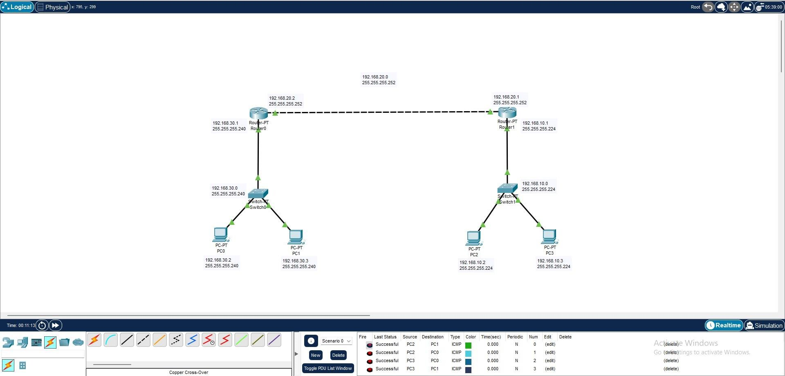

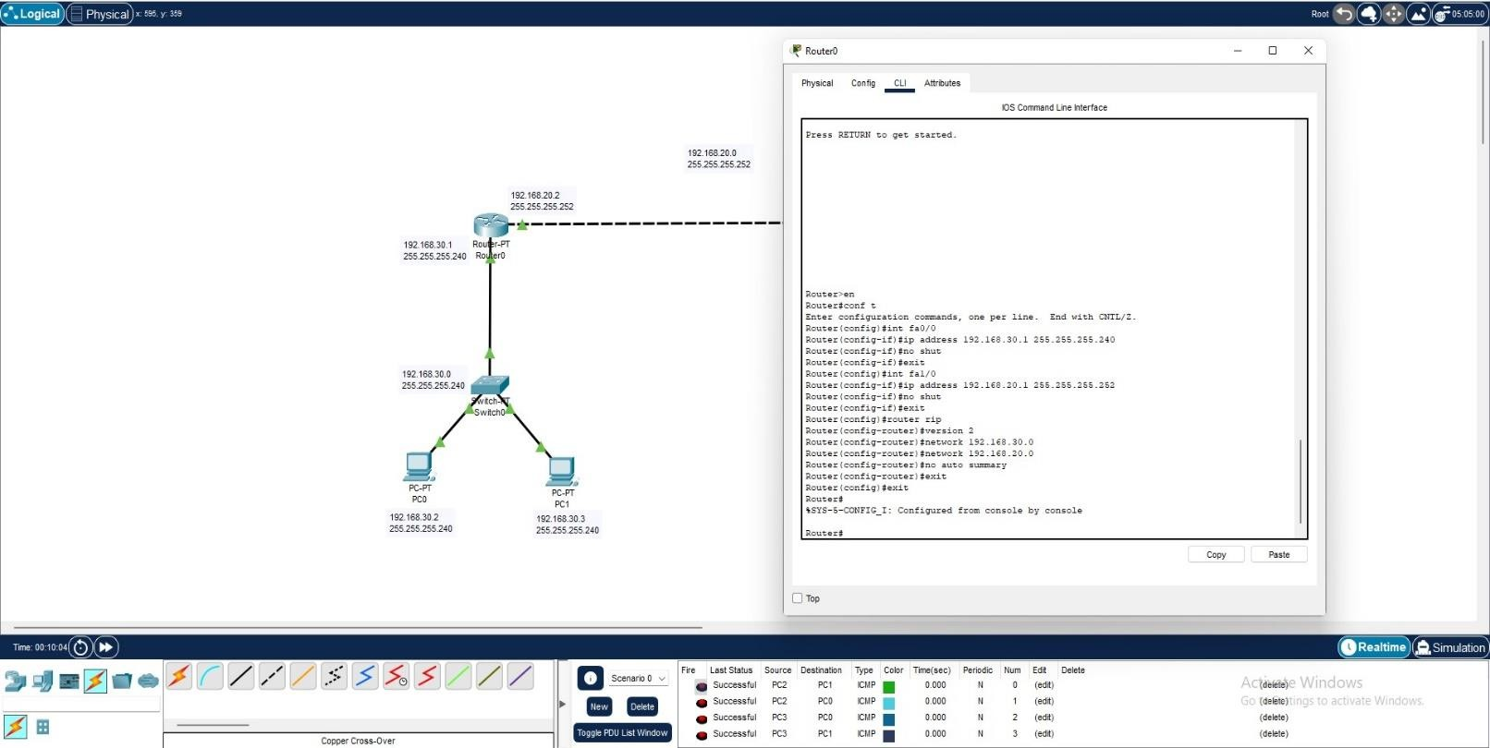

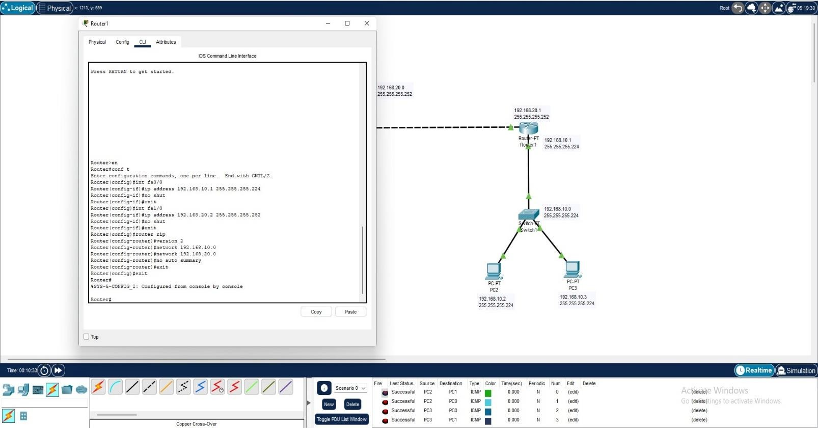

**Lab 9: Implementation of Single Area OSPF**

* **Procedure:**

1. **Open Packet Tracer:**
   * Launch Cisco Packet Tracer on your computer.
2. **Create a Network:**
   * Drag three routers onto the workspace and connect them in a triangular topology.
   * Connect a computer to each router using Ethernet cables.
3. **Configure IP Addresses:**
   * Assign IP addresses to each interface on the routers and computers.
4. **Enable OSPF:**
   * Access the CLI of each router.
   * Enable OSPF: router ospf 1.
   * Advertise connected networks: network <network address> area 0.
5. **Test Connectivity:**
   * Use the ping command to test connectivity between the computers.

# Output:

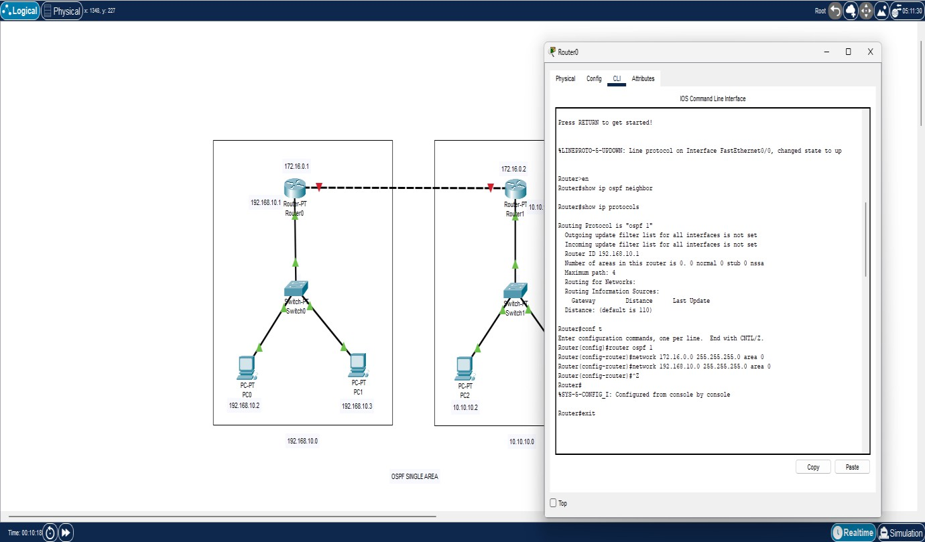

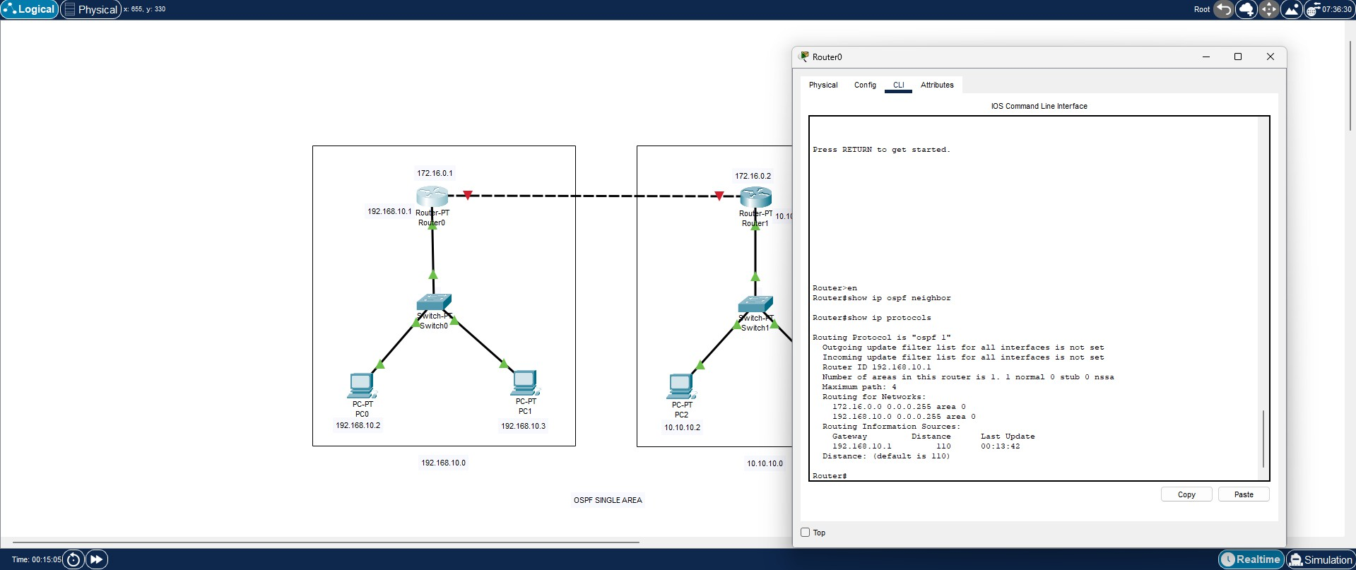

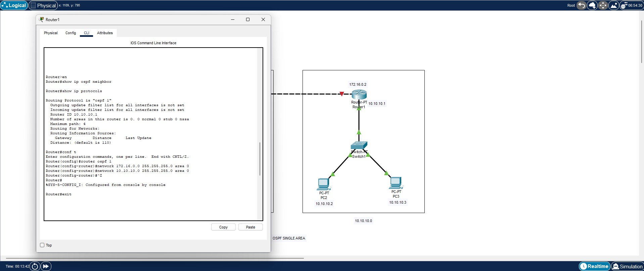

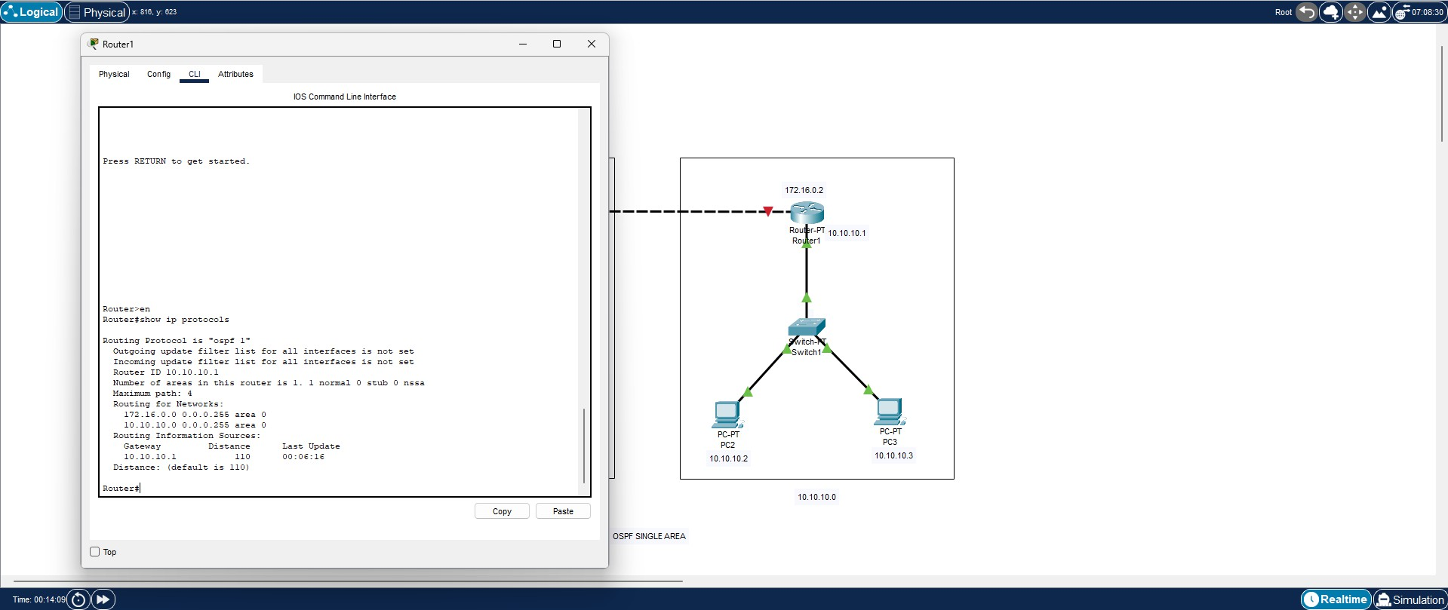

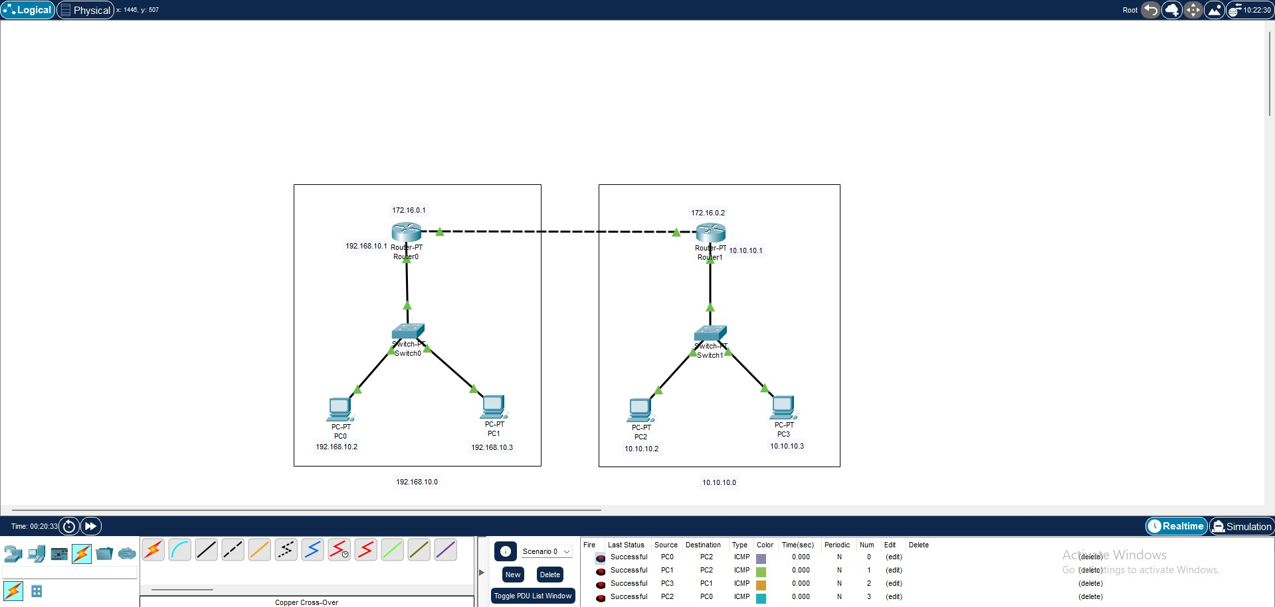

**Lab 10: Implementation of Multi Area OSPF**

* **Procedure:**

1. **Open Packet Tracer:**
   * Launch Cisco Packet Tracer on your computer.
2. **Create a Network:**
   * Drag four routers onto the workspace and connect them to form two separate OSPF areas with an Area 0 backbone.
   * Connect a computer to each router using Ethernet cables.
3. **Configure IP Addresses:**
   * Assign IP addresses to each interface on the routers and computers.
4. **Enable OSPF:**
   * Access the CLI of each router.
   * Enable OSPF on Area 0 routers: router ospf 1.
   * Advertise connected networks: network <network address> area 0.
   * Enable OSPF on Area 1 routers: router ospf 1.
   * Advertise connected networks: network <network address> area
5. **Test Connectivity:**
   * Use the ping command to test connectivity between the computers.

# Output:

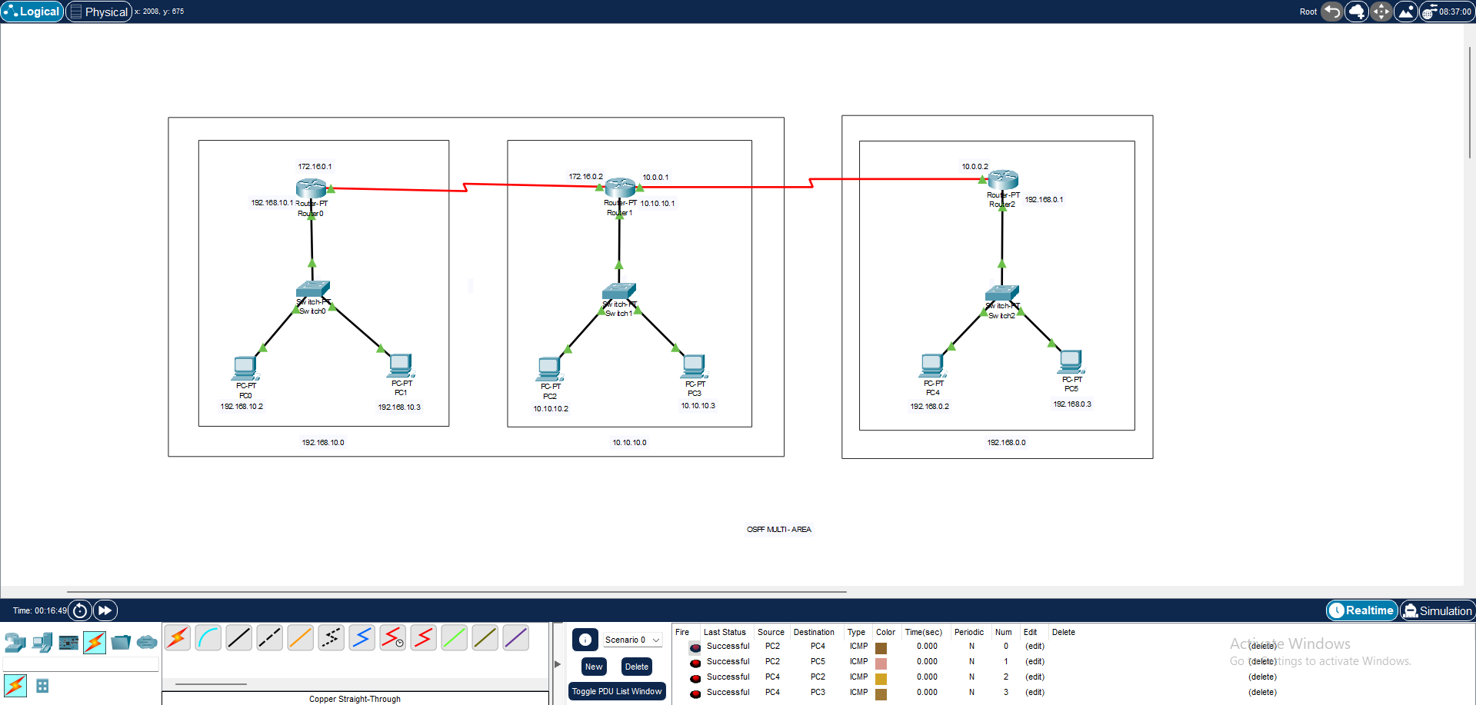

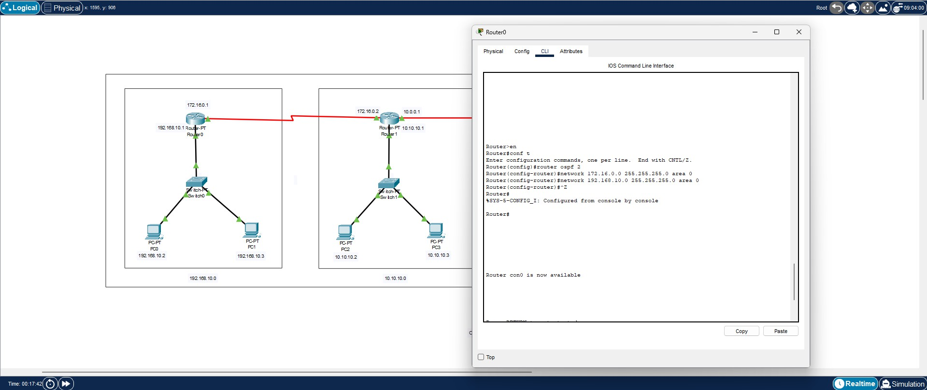

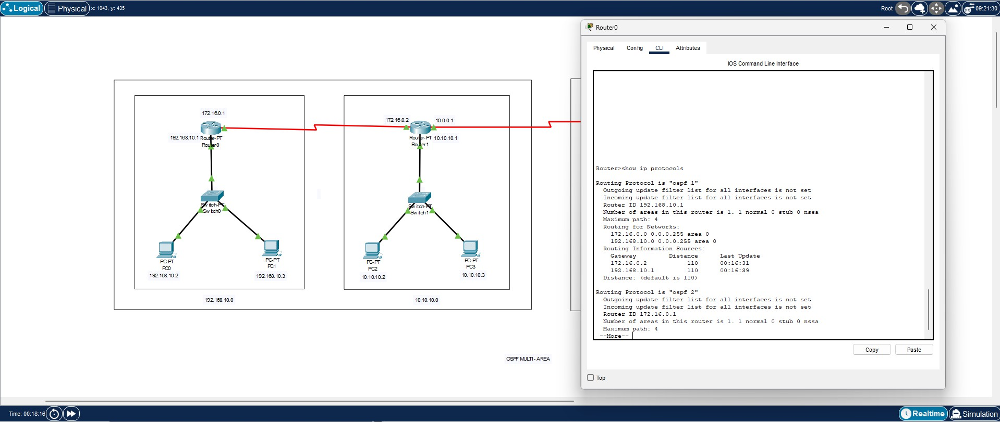

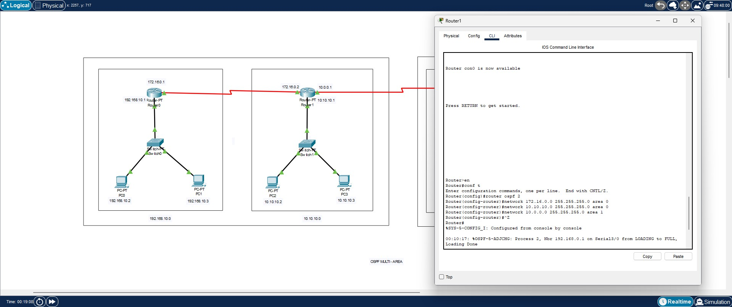

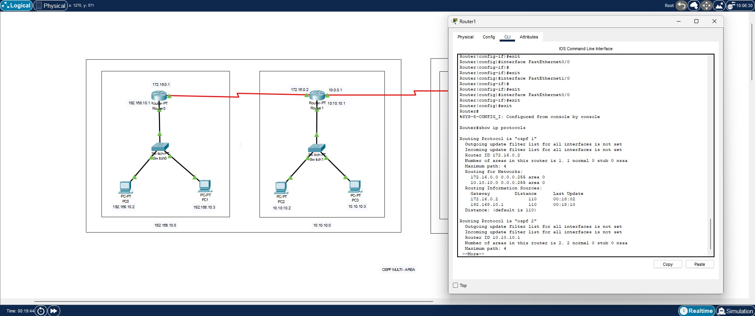

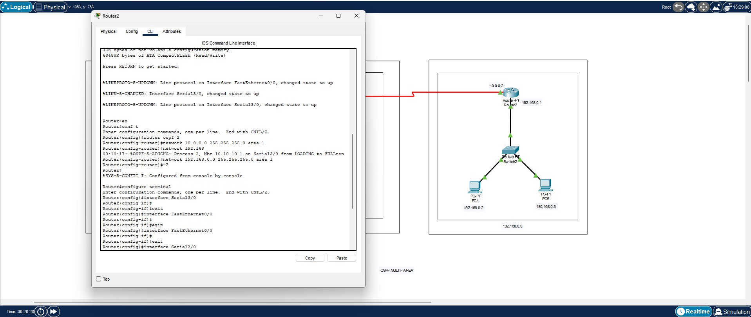

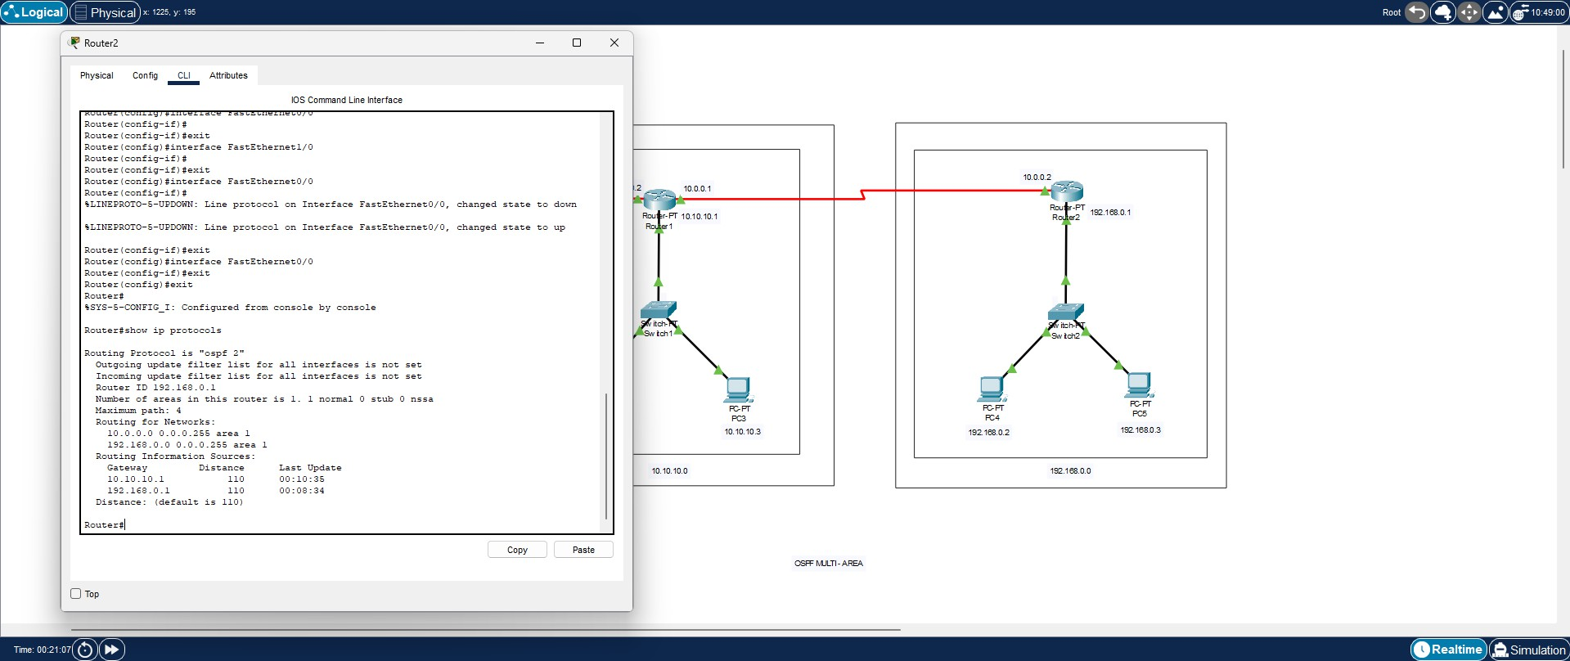

**Lab 11: PPP Configuration**

* **Procedure:**

1. **Open Packet Tracer:**
   * Launch Cisco Packet Tracer on your computer.
2. **Create a Network:**
   * Drag two routers onto the workspace and connect them using a serial connection.
   * Connect a computer to each router using Ethernet cables.
3. **Configure IP Addresses:**
   * Assign IP addresses to each interface on the routers and computers.
4. **Configure PPP:**
   * Access the CLI of each router.
   * Enter interface configuration mode for the serial interface: interface serial 0/0/0.
   * Enable PPP encapsulation: encapsulation ppp.
5. **Test Connectivity:**
   * Use the ping command to test connectivity between the computers.

# Output:

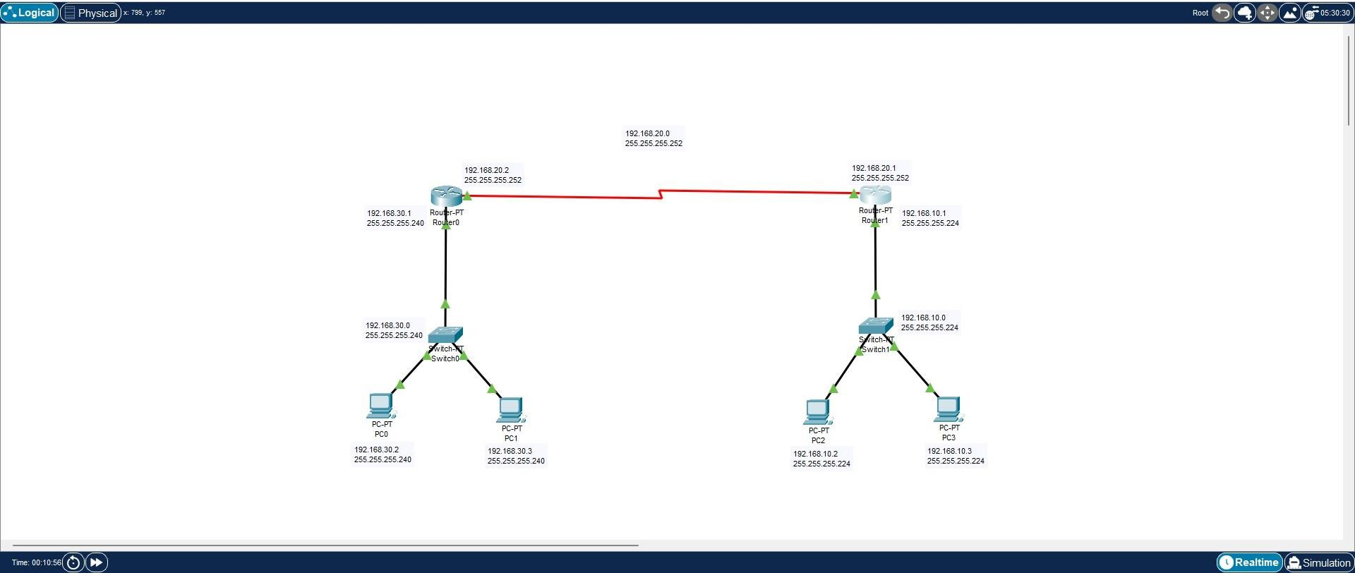

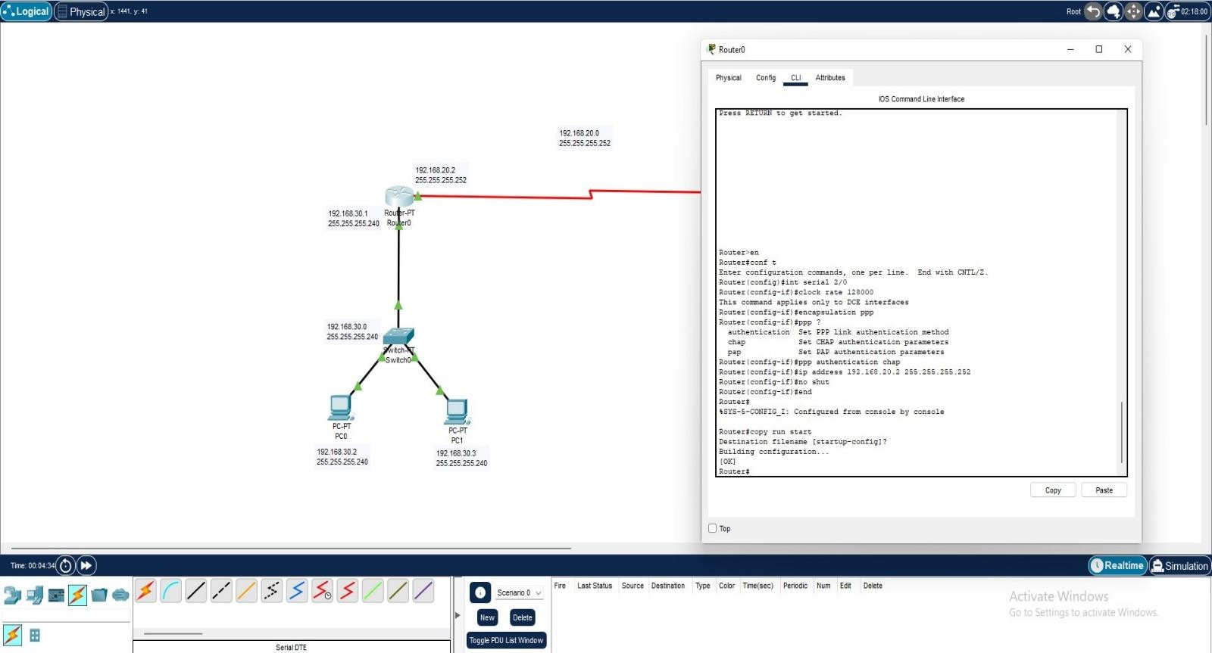

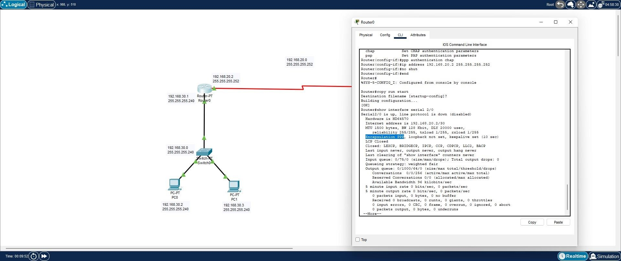

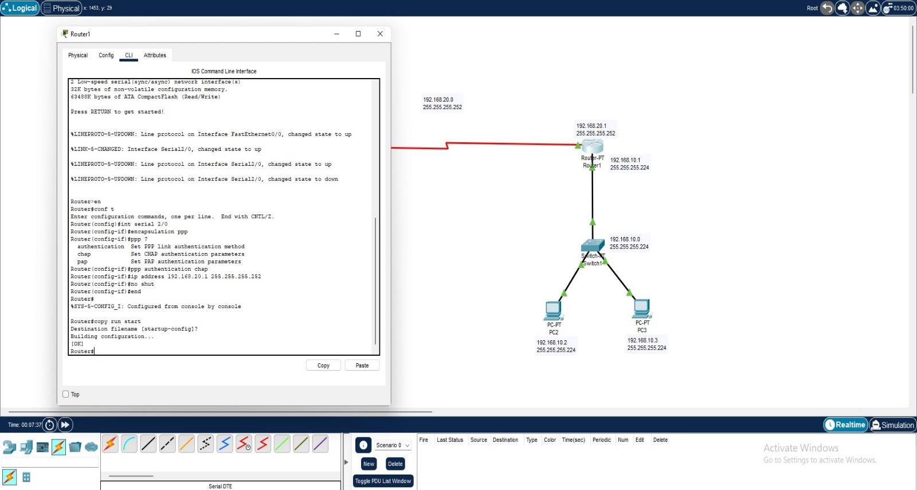

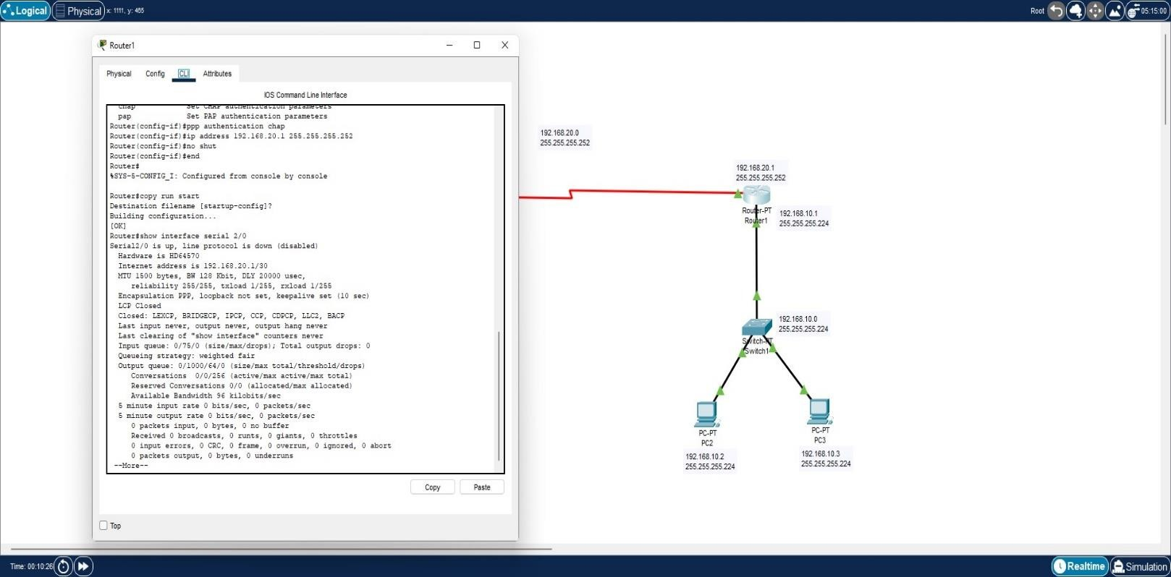

**Lab 12: HDLC Configuration**

* **Procedure:**

1. **Open Packet Tracer:**
   * Launch Cisco Packet Tracer on your computer.
2. **Create a Network:**
   * Drag two routers onto the workspace and connect them using a serial connection.
   * Connect a computer to each router using Ethernet cables.
3. **Configure IP Addresses:**
   * Assign IP addresses to each interface on the routers and computers.
4. **Configure HDLC:**
   * Access the CLI of each router.
   * Enter interface configuration mode for the serial interface: interface serial 0/0/0.
   * Enable HDLC encapsulation: encapsulation hdlc.
5. **Test Connectivity:**
   * Use the ping command to test connectivity between the computers.

**Output:**



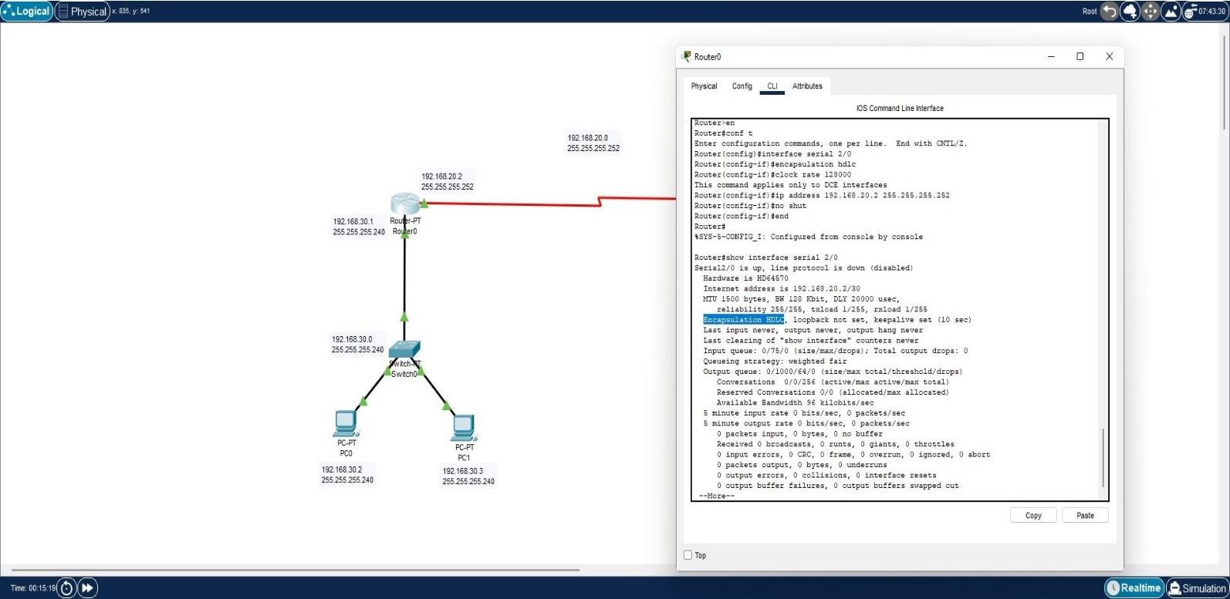

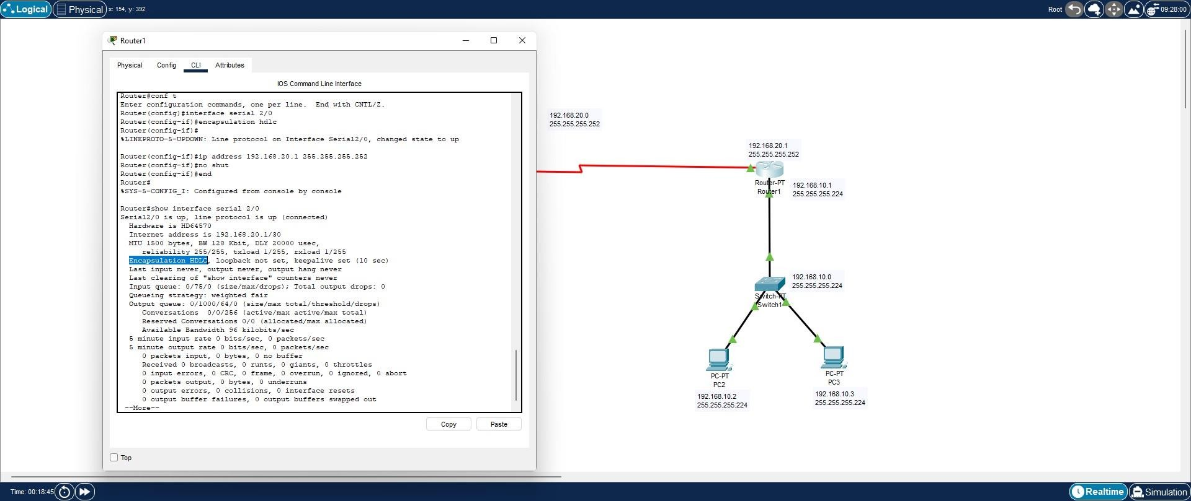

**Lab 14: Implementation of EIGRP**

● Procedure:

1. Open Packet Tracer:

■ Launch Cisco Packet Tracer on your computer.

2. Create a Network:

■ Drag three routers onto the workspace and connect them in a triangular

topology.

■ Connect a computer to each router using Ethernet cables.

3. Configure IP Addresses:

■ Assign IP addresses to each interface on the routers and computers.

4. Enable EIGRP:

■ Access the CLI of each router.

■ Enable EIGRP: router eigrp 1.

■ Advertise connected networks: network <network address>.

5. Test Connectivity:

■ Use the ping command to test connectivity between the computers**.**

